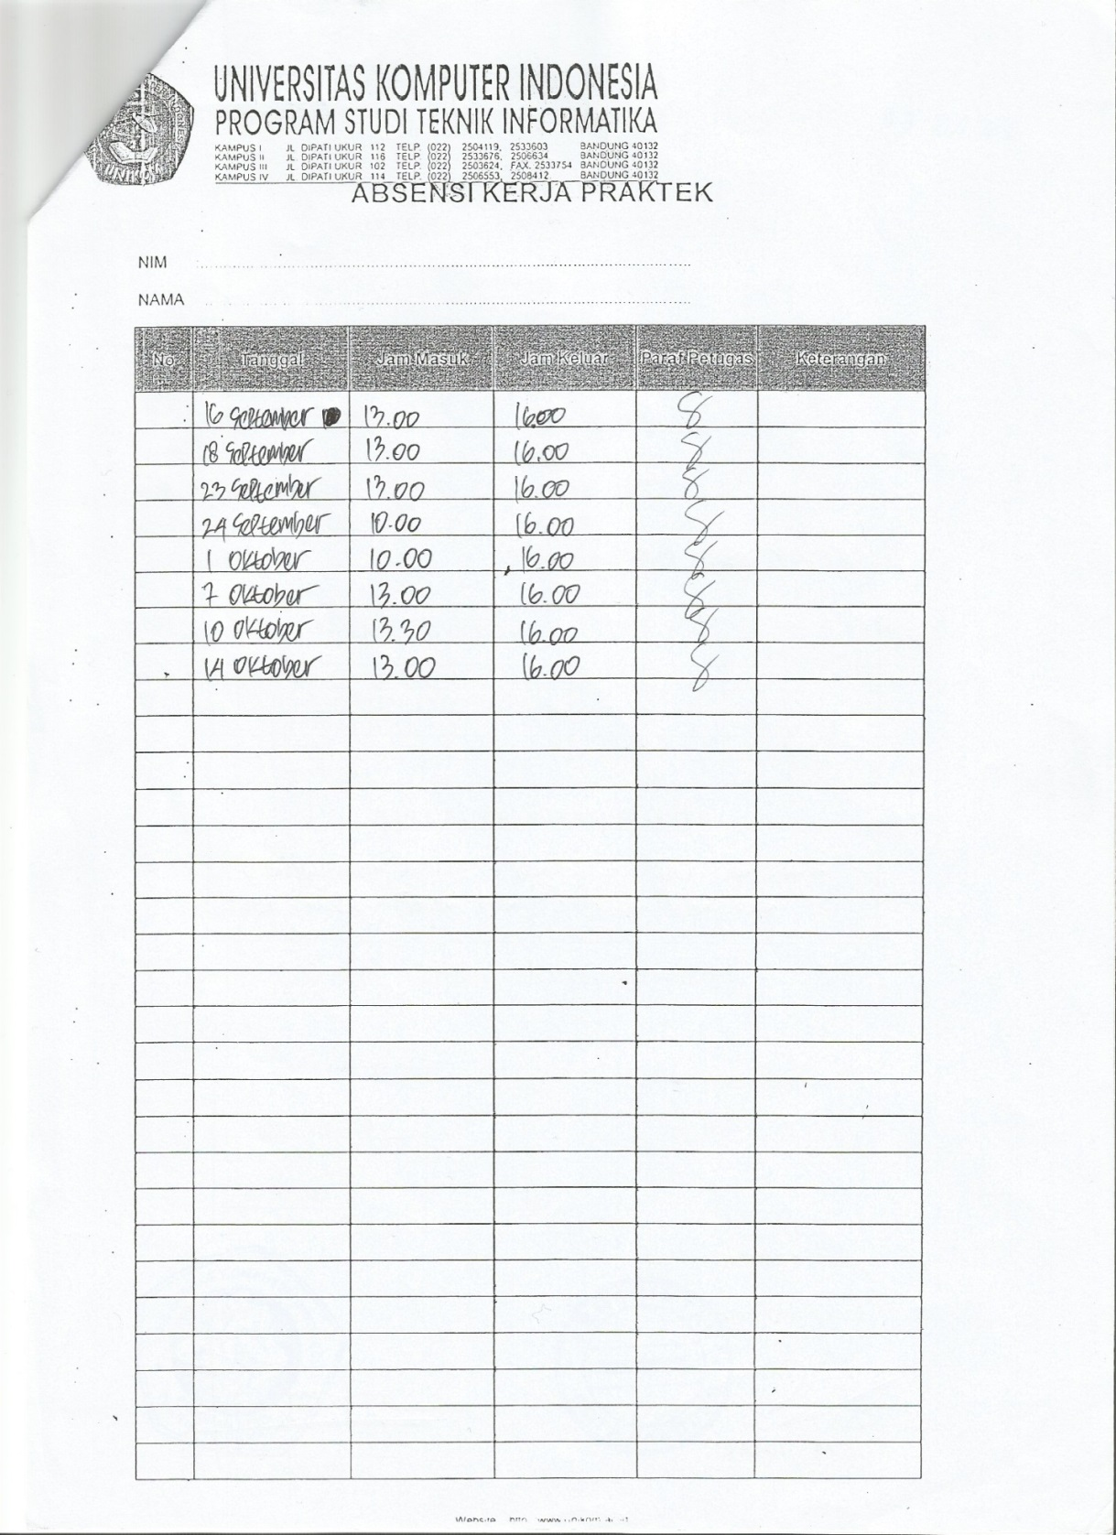

**Gambar 15 Presensi Ismail Zakky**